5 SIMPLE Steps to a Renewed Mind
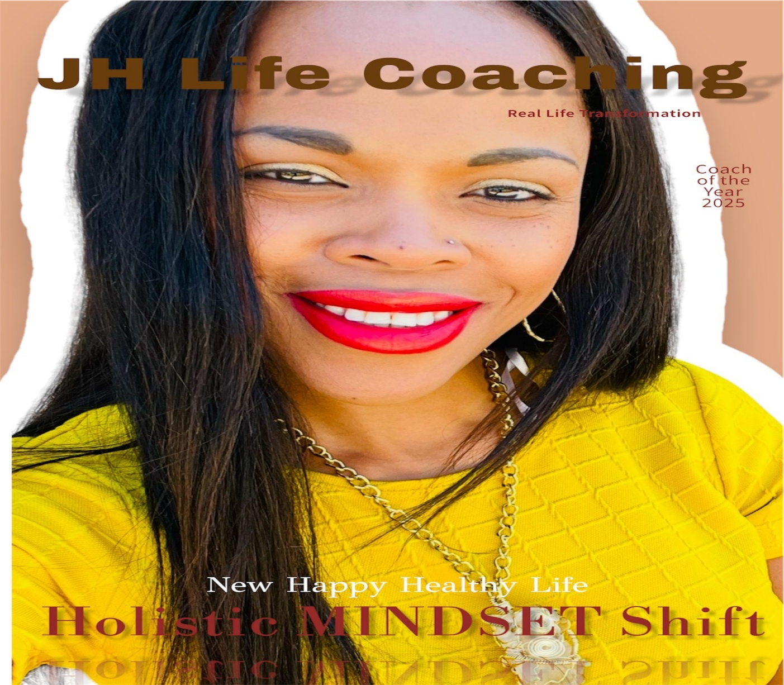

Dr. Nicolette Jarrett-Harris
Copyright: JH Coaching and Wellness Products, LLC

5 Proven Steps to a Renewed Mind
Hello! I’m Dr. Nicolette Jarrett-Harris, the founder of JH Coaching and Wellness Products, LLC. Our mission is to empower individuals every day by equipping them with the tools to take the first step towards self-development and create a more fulfilling life. In this eBook, you’ll discover 5 Proven Steps that will guide you on your journey to a Renewed Mind!
What is the role of Transformational Coach/Self Development Coach?
To CREATE and provide strategies that help people achieve goals.
To EMPOWER others to completely rethink what is possible for their life.
To helps others become AWARE of who they are and how to live more abundantly.
To SUPPORT individuals in becoming more aligned and focused to create a shift in their life.
DO YOU WANT TO?
Release Fear Based Living | Align with Self | Gain Clarity
Build Self Esteem | Love Yourself More | Be More Authentic
Heal Trauma | Change Careers | Communicate Better
Feel Empowered | Refocus your Energy | Walk in Purpose
Activate your Spiritual Gifts | Live Abundantly | Feel Peace
I know how eager you are to start this amazing healing journey!
This eBook, while SHORT is POWERFUL!
It will start you on the path to success and healing! The information I share with you will provide you with tools to effectively begin your personal journey to healing from the inside out.

When you’re ready lets talk about creating a personal healing plan specifically for you!
5 SIMPLE Steps to a Renewed Mind

- Remove Limiting Belief
What is a limiting belief?
A limiting belief is a manner of thinking that places a barrier in the mind on what a person can or cannot accomplish.
If you struggle with decreasing a limiting belief mindset and increasing the mindset of abundance, you are not alone.
Limiting Beliefs come forward in many ways. Below are a few ways we hear these limitations in our mind:
I will never be able to change jobs due to….
If I had more money, I would be able to…
I don’t have the skills I need to…
I am not smart enough to….
Limiting Beliefs trick our mind into staying stagnant which hinders our development and ability to grow.
For this reason, we must work daily to expand our mind.
3 ways to Decrease Limiting Beliefs!
*Operate in the Present
Operating in the Present allow us to become aware of our thoughts as they happen. The more aware we are of our thoughts the easier it is to train our brains to think in terms of “I can” verses “I cannot.”
Task: Get a glass of water. Sit in a comfortable place. Hold the water in your hand. Do not drink the water. Bring your awareness to the glass of water in your hand and how the glass feels. Notice the temperature of the glass and how your hands feels as you hold it. Begin to think about the benefits that drinking this glass of water would have on your body. When you are ready, drink the water. Pay attention to how the water feels as it goes down your throat, how you feel and what you are thinking. This is how you operate in the present and begin the journey to a renewed mind.
*Train your Brian to Think Positive
Our brains are programmable and do not know that difference between reality and fiction. Meaning that whatever you tell yourself about your current ability, your brain believes. Therefore, one should strive to only tell themselves positive things and should resist the urge to speak negatively to one’s own mind.
Task: Focus all your attention on positive thoughts for 3 minutes. Any time a thought enters your mind other than the thought you are focusing on, bring your awareness back to the original positive though. Do this several times a day to reset and train your brain on how to gain awareness of being present in the present.
*Have PILLOW TALK with yourSELF
No one is exempt from completing daily tasks. Whether it is at work or in your daily life. Some tasks we naturally do well, while others we work on daily; the goal is to improve each day.
Task: Each night before going to bed have a conversation with yourself about your day. Tell yourself what you did well and make suggestions to yourself on how you can improve your goals for the next day. When speaking with yourself be sure to use accountable talk that supports a RENEWED MINDSET.
Example: Today I did well; I focused on my work, but I stayed in the breakroom to long. Tomorrow, I will set a timer when I go on break, so I can make sure I master my time.
CLICK HERE TO SCHEULE A TRANSFORMATIONSAL COACHING SESSION

- Expand the Mind

What does it mean to Expand the Mind?
Expanding the Mind plays directly off Removing Limiting Belief Systems because belief systems prevent the mind from expanding in a positive manner.
Therefore, once we have worked to remove the limiting belief systems, we must now work to expand our mind and challenge it to see, feel and seek what we once believed was impossible.
This means that we must become conscious of the health of our unconscious mind, so that we can begin to train our brains to operate fully in the mindset of growth an abundance.

Expand the Mind with Meditation!
What is Meditation?
Meditation is a daily practice that supports individuals in the expanding the mind by providing the opportunity to LISTEN to ourselves and HEAR our inner voice. This active listening often leads to increased clarity and promotes the expansion of a healthy mind.
<<<<<Subscribe to my YouTube >>>>
CLICK HERE TO SCHEULE A TRANSFORMATIONSAL COACHING SESSION

- Mental Health Recharge
Mental Health is an important aspect of the healing process. This is because our mindset directly effects our mental health; therefore, it is important to understand the signs that we need a mental health recharge and how to support ourselves during the recharge process.

Signs we need Mental Health Recharge
Depression | Low Appetite | Inability to Focus
Anxiety | Mood Swings | Tired
Muscle Aches | Increased Substance Abuse | Decreased Coping Skills

5 Ways to Mentally Recharge ourselves?
1. Spend Time Alone (Try journaling or simply sitting with yourself without distraction and allowing your mind to rest.)
2. Relax at the Park (Take a walk, find a trail, ride a bike, sit on the grass)
3. Listen to Music with Healing Frequencies (I suggest 432 Hz for Clarity)
4. Take a 20 to 30 Minute Healing Bath (Use 2 tablespoons of Sea Salt, 2 tablespoons of Olive Oil, a hand full of rose petals and a pinch of bubbles bath, as you get in the water say out loud, “This is a Healing Bath, and I am Healing from within.”)
5. Try Something New (Do something out of the ordinary even if it is taking a different route home from work.)

CLICK HERE TO SCHEULE A TRANSFORMATIONSAL COACHING SESSION

- Create the Mindset of Success
How do we create a Mindset of Success?
Creating the Mindset of Success is about training your brain to only think about those things that we want and not to think about the things that we do not want.
What does this mean?
This means that we must LITERALY reteach our brains how to think!!! More specifically, we must “RESET” the permission we give our brains on how we are allowed to handle situations in the physically and mental world. This means that how we interact with our thoughts must be calculated and filtered so that the correct information is downloaded into our energetic frequency. People who stay in low vibrations carry low vibrational though patterns. The same goes for people who stay in high vibrations. For this reason, we must diligently work to stay in a high vibrational thought pattern to create a mindset of success.
For example: The covid-19 pandemic has created fear throughout the world that has contributed to increased anxiety and depression, which are both low vibrational feelings. A person who is creating a mindset of success would not think about the Covid-19 pandemic in a limiting low vibrational manner. A person creating a mindset of success would focus on only the positive outcomes created by the pandemic (no matter how small) which would in return, changes the limiting narrative and allow the mindset of success to flow freely.

CLICK HERE TO SCHEULE A TRANSFORMATIONSAL COACHING SESSION

- Goal Setting with a Renewed Mind
As we complete each of the aforementioned steps a renewing of our minds will begin to take place. This renewed mind will support us on our journey to healing as we transition into a happier and healthier version of ourselves.
This new version does not have the capacity to operate in a mundane manner and must continue to attain knowledge and evolve. Goal setting is a great way to continue this process without becoming overwhelmed.
When setting goals, it is important that each goal is measurable (time factored), attainable, flexible, and paired with action. Use the IAG Short Term Goals example below to create an attainable short term’s goal that will support you in moving forward to a Renewed Mindset!
What is a Short-Term Goal?
Short-terms goals is a goal that can be accomplished in a year or less. (For this example, our Short-Terms Goal will be less than a month).
*Note: When you write your goals, they need to be measurable (time-factored), attainable, flexible, and paired with action.
Undefined Short Term Goal Example:
I want to start a new online business.
Defined Short Term Goal Example:
In the next week, I will set aside time to map out the type of business I want to achieve. I will research other companies and make a list of what I need to do to get my online business started.
Goal Broken Down: In the next week (measurable and attainable), I will set aside time to map out the type of business I want to achieve (realistic). I will research other companies and make a list of what I need to do to get my online business started (flexible and paired with action).
Write a Short-Term Goal (Pay attention to if the goal is measurable (time-factored), attainable, flexible, and paired with action).
__________________________________________________________________________________________________________________________________________________________________________________________________________________________________________________________________________________________________
<<<<IDEA ACTION GOAL SETTING MASTER CLASS COMING SOON>>>>
<<<< SUBCRIBE More Tips on YOUTUBE >>>>
Renewing Your Mind allows one to operate on a Higher Frequency.
This frequency has a Rippling Effect on everyone we encounter and assists in the Ascension of the Planet.
Dr. Nicolette Jarrett-Harris
CLICK HERE TO SCHEULE A TRANSFORMATIONSAL COACHING SESSION

If you made it this far you are READY TO GROW!
Congratulations on “Taking the First Step” to a more rewarding Life!

I wrote this eBook to SUPPORT you in achieving everything you want!
You are now ready to invest in yourself and begin the journey to prosperity and healing.
Commit to learning more and stay positive during your journey. You will be able to share your success story later and support others in there healing journey.
I you haven’t already, go ahead and click the button to explore the many learning opportunities available to you for SELF DEVELPMENT and TRANSFORMATIONAL HEALING .

Stay in Touch ~ Dr. Nicolette Jarrett-Harris
IG: instagram.com/drnjarrettharris  Youtube: Dr. Nicolette Jarrett-Harris - YouTube | TikTok: tiktok.com/@drnjarretharris  Website: www.JHCoachingandWellness.com
Email: JHCoaching.Wellness@gmail.com | Esty Shop: etsy.com/shop/324Jewels?ref=profile_header


Dr. J.Dowling
Copyright: Brand ~ 324 & Anomaly 324 ~ Coaching and Wellness, LLC

